Measurement Protocol PAX

# General Information:

|  |  |  |
| --- | --- | --- |
| Test date: 19/02/20 | Date prev. test: 09/11/19 | Test number: 2 |
| Tested by: Alex Pollak | PAX number: PB-037 | Installed at ant.: 4G |
| Comments: X-Pol has a higher gain than the Y-Pol, hence detector value should be set to a | | |
| lower value in order to have the same output power. | | |
| Dip in passband of X-Pol at 1.9GHz | | |
|  | | |
| Known problems: | | |
| . | | |
|  | | |
|  | | |

# Setup:

|  |  |  |  |
| --- | --- | --- | --- |
| Power supply: | OK 🗹 NOK 🗆 | Communication: | OK 🗹 NOK 🗆 |
| Supply current +6V: 1.126mA | | ssh obs@antcntl | |
| Supply current -6V: 0.110mA | | ssh ataant@ant0 | pw: q@n@t |
| Supply current +5V: 0.040mA | | telnet pax | “help” |
|  | | CTRL + ] | “close” |

# RF Test with VNA:

### VNA Setup:

|  |  |  |
| --- | --- | --- |
| Load configuration: Passband_PAX.csa | | |
| Freq Start: 1.0 GHz | Freq Stop: 13.0 GHz | Power Level: -20 dBm |
| Averaging: enabled | Averaging count: 15 | N. Points: 801 |
| VNA : Agilent N5230C 10MHz - 20GHz | | |

|  |  |  |  |  |
| --- | --- | --- | --- | --- |
| VNA to PAX connection: | 1m ABC-CA18 Cable + 20dB Attenuator | | | |
| Input Power Level to PAX: (Measured) | @1GHz:  -40.2dBm | @4GHz:  -40.7dBm | @8GHz: -41.2dBm | @12GHz: -41.4dBm |

|  |  |
| --- | --- |
| PAX to VNA connection: | 2m Fibre Cable + Fibre Diode + AOX Amplifier + 1m ABC-CA18 Cable |

### Measured Passband with Attenuator set to 7dB each (Complete Link):

|  |
| --- |
| X |

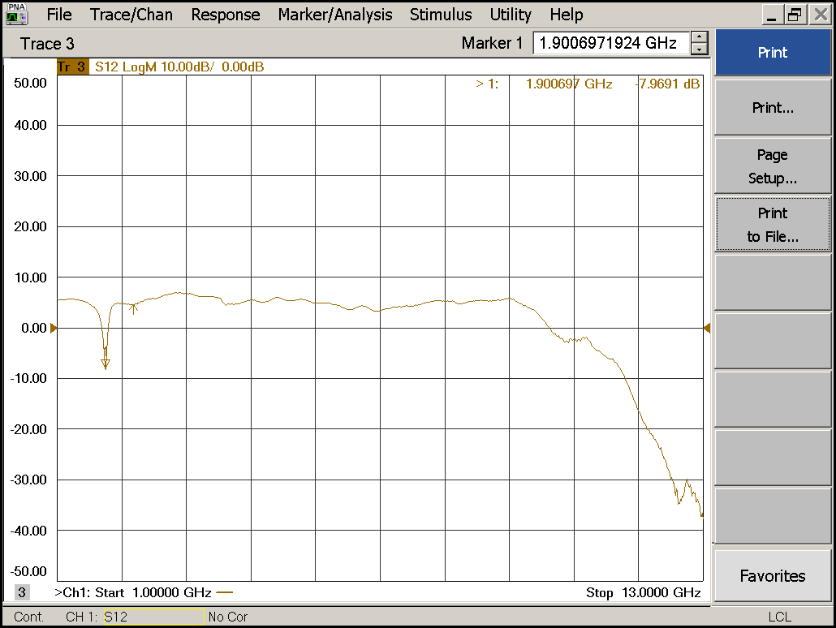

|  |  |  |  |
| --- | --- | --- | --- |
| Flatness: | OK 🗹 NOK 🗆 | Unwanted Features: | Yes ⮽ No 🗆 |

|  |
| --- |
| Y |

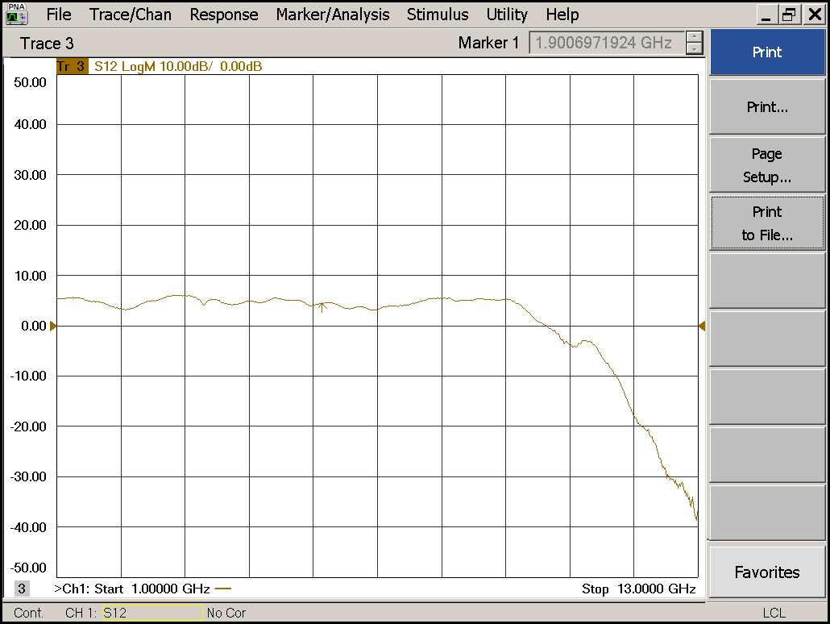

|  |  |  |  |
| --- | --- | --- | --- |
| Flatness: | OK 🗹 NOK 🗆 | Unwanted Features: | Yes 🗆 No 🗹 |

### Power Sweep (Complete Link):

|  |  |  |
| --- | --- | --- |
| Load configuration: Power_Sweep_PAX.csa | | |
| Power Start: -40dBm | Power Stop: -20dBm | Frequency : 4.0GHz |
| PAM Attenuator: 0dB |  | N. Points: 801 |

|  |
| --- |
| X |

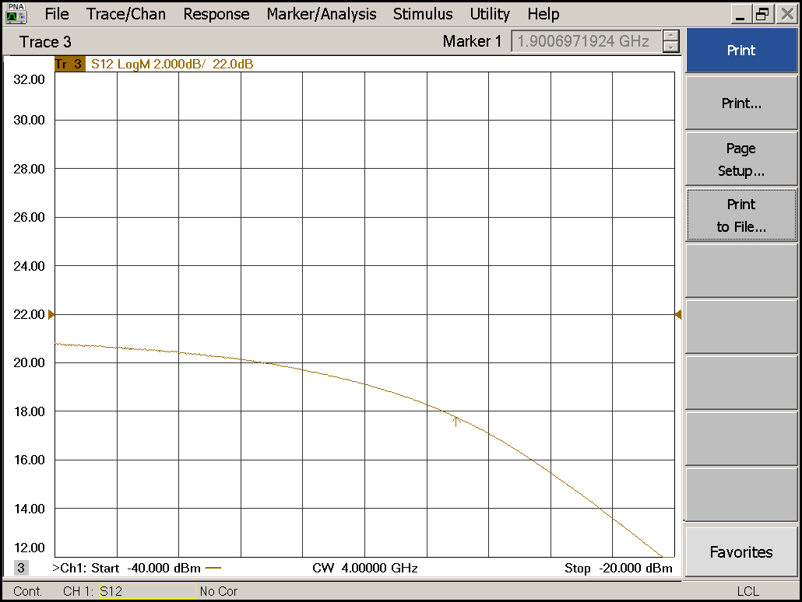

|  |  |  |  |
| --- | --- | --- | --- |
| Compression point: | OK 🗹 NOK 🗆 | Unwanted Features: | Yes 🗆 No 🗹 |

|  |
| --- |
| Y |

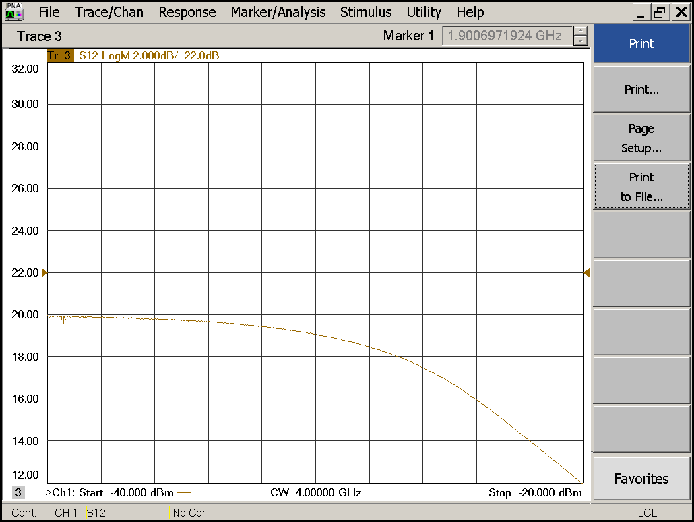

|  |  |  |  |
| --- | --- | --- | --- |
| Compression point: | OK 🗹 NOK 🗆 | Unwanted Features: | Yes 🗆 No 🗹 |

### Detector Calibration and Attenuator Sweep Pol X:

|  |  |  |
| --- | --- | --- |
| Load configuration: Detector_Calibration_PAX.csa | | |
| Freq : 4.0 GHz | Power Level: -20dBm | Sweep Time: -20sec |
| Sweep Mode: CW | Power Level at PAX Input (Measured): -40.6dBm | |

|  |  |  |  |  |
| --- | --- | --- | --- | --- |
| X | | | | |
| CW Input Power [dBm]: | Attenuator Value A [dB]: | Attenuator Value: B [dB]: | Detector Value: | Power Meter  Value [dBm]: |
| -40.6 | 0 | 0 | - | 14.1 |
| -40.6 | 0 | 3 | - | 14.0 |
| -40.6 | 0 | 6 | - | 12.8 |
| -40.6 | 0 | 9 | 0.8591 | 10.2 |
| -40.6 | 0 | 12 | 0.7471 | 7.1 |
| -40.6 | 0 | 15 | 0.4675 | 4.3 |
| -40.6 | 0 | 18 | 0.2542 | 1.0 |
| -40.6 | 0 | 21 | 0.1410 | -2.1 |
| -40.6 | 3 | 21 | 0.0719 | -5.3 |
| -40.6 | 6 | 21 | 0.0371 | -8.3 |
| -40.6 | 9 | 21 | 0.0191 | -11.3 |
| -40.6 | 12 | 21 | 0.0101 | -14.4 |
| -40.6 | 15 | 21 | 0.0058 | -17.2 |
| -40.6 | 18 | 21 | 0.0032 | -20.6 |
| -40.6 | 21 | 21 | 0.0022 | -23.7 |
| -40.6 | 24 | 21 | 0.0017 | -26.7 |
| -40.6 | 27 | 21 | 0.0014 | -29.7 |
| -40.6 | 30 | 21 | 0.0013 | -33.0 |
| -40.6 | 30 | 24 | 0.0012 | -35.7 |
| -40.6 | 30 | 27 | 0.0012 | -38.1 |
| -40.6 | 30 | 30 | 0.0011 | -40.5 |

|  |  |  |
| --- | --- | --- |
| Use Noise Source: Atlantic AS6333 | | |
| Freq : 1.0 - 12.0GHz | Power Level: -41.8dBm |  |
| DC Supply: 28V |  | |

|  |  |  |  |  |
| --- | --- | --- | --- | --- |
| X | | | | |
| CW Input Power [dBm]: | Attenuator Value A [dB]: | Attenuator Value: B [dB]: | Detector Value: | Power Meter  Value [dBm]: |
| -41.8 | 0 | 0 | - | 12.2 |
| -41.8 | 0 | 3 | - | 10.9 |
| -41.8 | 0 | 6 | - | 8.9 |
| -41.8 | 0 | 9 | - | 6.5 |
| -41.8 | 0 | 12 | 0.8585 | 3.7 |
| -41.8 | 0 | 15 | 0.5658 | 1.0 |
| -41.8 | 0 | 18 | 0.3101 | -2.2 |
| -41.8 | 0 | 21 | 0.1737 | -5.1 |
| -41.8 | 3 | 21 | 0.0947 | -8.1 |
| -41.8 | 6 | 21 | 0.0474 | -11.2 |
| -41.8 | 9 | 21 | 0.0251 | -14.1 |
| -41.8 | 12 | 21 | 0.0129 | -17.2 |
| -41.8 | 15 | 21 | 0.0078 | -19.9 |
| -41.8 | 18 | 21 | 0.0043 | -23.2 |
| -41.8 | 21 | 21 | 0.0028 | -26.3 |
| -41.8 | 24 | 21 | 0.0021 | -29.4 |
| -41.8 | 27 | 21 | 0.0017 | -32.2 |
| -41.8 | 30 | 21 | 0.0016 | -35.5 |
| -41.8 | 30 | 24 | 0.0015 | -37.9 |
| -41.8 | 30 | 27 | 0.0015 | -40.0 |
| -41.8 | 30 | 30 | 0.0014 | -41.8 |

### Detector Calibration and Attenuator Sweep Pol Y:

|  |  |  |
| --- | --- | --- |
| Load configuration: Detector_Calibration_PAX.csa | | |
| Freq : 4.0 GHz | Power Level: -20dBm | Sweep Time: -20sec |
| Sweep Mode: CW | Power Level at PAX Input (Measured): -40.6dBm | |

|  |  |  |  |  |
| --- | --- | --- | --- | --- |
| Y | | | | |
| CW Input Power [dBm]: | Attenuator Value A [dB]: | Attenuator Value: B [dB]: | Detector Value: | Power Meter  Value [dBm]: |
| -40.6 | 0 | 0 | -- | 14.1 |
| -40.6 | 0 | 3 | - | 14.1 |
| -40.6 | 0 | 6 | - | 12.8 |
| -40.6 | 0 | 9 | 0.8589 | 10.2 |
| -40.6 | 0 | 12 | 0.7881 | 7.2 |
| -40.6 | 0 | 15 | 0.5014 | 4.5 |
| -40.6 | 0 | 18 | 0.2790 | 1.2 |
| -40.6 | 0 | 21 | 0.1552 | -1.9 |
| -40.6 | 3 | 21 | 0.0768 | -5.3 |
| -40.6 | 6 | 21 | 0.0395 | -8.3 |
| -40.6 | 9 | 21 | 0.0204 | -11.3 |
| -40.6 | 12 | 21 | 0.0108 | -14.4 |
| -40.6 | 15 | 21 | 0.0059 | -17.3 |
| -40.6 | 18 | 21 | 0.0033 | -20.6 |
| -40.6 | 21 | 21 | 0.0022 | -23.8 |
| -40.6 | 24 | 21 | 0.0017 | -26.7 |
| -40.6 | 27 | 21 | 0.0013 | -29.9 |
| -40.6 | 30 | 21 | 0.0013 | -33.2 |
| -40.6 | 30 | 24 | 0.0011 | -35.8 |
| -40.6 | 30 | 27 | 0.0011 | -38.2 |
| -40.6 | 30 | 30 | 0.0011 | -40.5 |

|  |  |  |
| --- | --- | --- |
| Use Noise Source: Atlantic AS6333 | | |
| Freq : 1.0 - 12.0GHz | Power Level: -41.8dBm |  |
| DC Supply: 28V |  | |

|  |  |  |  |  |
| --- | --- | --- | --- | --- |
| Y | | | | |
| CW Input Power [dBm]: | Attenuator Value A [dB]: | Attenuator Value: B [dB]: | Detector Value: | Power Meter  Value [dBm]: |
| -41.8 | 0 | 0 | - | 12.2 |
| -41.8 | 0 | 3 | - | 11.0 |
| -41.8 | 0 | 6 | - | 9.1 |
| -41.8 | 0 | 9 | - | 6.7 |
| -41.8 | 0 | 12 | 0.8586 | 3.9 |
| -41.8 | 0 | 15 | 0.6276 | 1.3 |
| -41.8 | 0 | 18 | 0.3489 | -1.8 |
| -41.8 | 0 | 21 | 0.1959 | -4.8 |
| -41.8 | 3 | 21 | 0.1065 | -7.8 |
| -41.8 | 6 | 21 | 0.0541 | -10.9 |
| -41.8 | 9 | 21 | 0.0285 | -13.8 |
| -41.8 | 12 | 21 | 0.0147 | -16.8 |
| -41.8 | 15 | 21 | 0.0087 | -19.6 |
| -41.8 | 18 | 21 | 0.0047 | -22.9 |
| -41.8 | 21 | 21 | 0.0030 | -26.0 |
| -41.8 | 24 | 21 | 0.0021 | -29.0 |
| -41.8 | 27 | 21 | 0.0018 | -31.8 |
| -41.8 | 30 | 21 | 0.0015 | -35.2 |
| -41.8 | 30 | 24 | 0.0013 | -37.6 |
| -41.8 | 30 | 27 | 0.0014 | -39.6 |
| -41.8 | 30 | 30 | 0.0014 | -41.5 |

# LNA Bias Supply:

Note that the bias supply is tested without an LNA connected to the PAX box!

|  |  |
| --- | --- |
| Enable Supply: “lnabiaslatch” | Disable Supply: “lnabiasoff” |

|  |  |  |  |
| --- | --- | --- | --- |
| X | | Y | |
| Vg: |  | Vg: |  |
| Vd: |  | Vd: |  |
| Vm: |  | Vm: |  |
| Id: |  | Id: |  |
| Bias Supply: OK 🗹 NOK 🗆 | | Bias Supply: OK **🗹** NOK 🗆 | |

# Inspection:

### Visual:

|  |  |  |
| --- | --- | --- |
| Fibre Connectors Clean | Comments: | OK 🗹 NOK 🗆 |
| Fibre Connector Mechanical | Comments: | OK **🗹** NOK **🗆** |
| RF Cable | Comments: | OK **🗹** NOK **🗆** |
| RF Connectors Clean | Comments: | OK **🗹** NOK **🗆** |

### Functions:

|  |  |  |
| --- | --- | --- |
| Read Temperature Value | Comments: 30.4 | OK 🗹 NOK 🗆 |
| LNA Settings | Comments: | OK 🗆 NOK **🗆** |
| Temperature Stabilisation | Comments: | OK 🗆 NOK **🗆** |
| Software Version: | Date: 2007/11/15 18:00:00 Revision: 1.10 pax controller | OK **🗹** NOK **🗆** |